



**PROJECTOBJECTS ANALYTICS**

**Web Dashboard – JSON APIs User Manual**

Revision: 1

Document no: 1

Period: 2021

**Author: Swati Singh**

**Table of Contents**

Scope of Document 3

General 3

JSON APIs 4

ProjectRegisterDataV2 5

ProjectHealthDataV2 7

TeamSpaceRegisterV2 9

ProjectBasicCostAnnualPhasingV2 12

BasicCostSumMonthlyPhasingByProjects 15

PortfolioMetricV2 18

GenericResourceAvailabilityViewV2 21

ScheduleDataV2 24

TTReport 27

PortfolioProjectRegister 28

GroupDetails 31

AuditTrail 32

UserDetails 33

StandardCodes 35

StandardCodesDataExtendedLibrary 36

LastPublishedDateTime 37

# Scope of Document

This document describes the details of exposed JSON APIs released at Analytics environment that can be used for Dashboard Reporting Purpose.

# General

The below APIs are built based on the PO Application Module Structure containing Ideas, Project, Resource, Cost, Portfolio, Time Sheets, Users, Groups, Standard Codes & TeamSpace related information.

There are two versions of APIs available at Analytics environment Version one & Version 2 which are Postfixed as V2.

Whereas V2 APIs contains limited set of Project Form Fields (Max 15) which can be provided by the End-User with the possibility to select the choice of fields that can be included in the V2 APIs from application UI. To improve the Performance of dashboards.

Excluding ProjectRegisterDataV2 API It includes all the Project form fields.

**To Setup the V2 APIs Choice of Project form fields configuration please follow the steps mentioned below:**

1. **Login** into the System.
2. Go to Application **Company** **Settings**.
3. Open the **Form Builder** Settings.
4. Select Form as **Project** from top **drop-down** list.
5. Open the **configuration settings** of your Project Form of required Process.
6. Go to **DASHBOARD FIELDS** Tab.
7. **Move** required fields from Available section to **Selected fields** section which you want to include in V2 APIs.
8. **Save** your changes.
9. **Publish** the Reporting APIs to reflect the changes in Version 2 APIs.

**NOTE:** The below used data is for demo purpose only. It has no relation with actual data of **Customer**.

# JSON APIs

List of JSON APIs versions available for customer usage.

* ProjectRegisterData
* ProjectRegisterDataV2
* ProjectHealthData
* ProjectHealthDataV2
* TeamSpaceRegisterData
* TeamSpaceRegisterDataV2
* ProjectBasicCostAnualPhasing
* ProjectBasicCostAnnualPhasingV2
* BasicCostSumMonthlyPhasingByProjects
* PortfolioMetric
* PortfolioMetricV2
* GenericResourceAvailabilityView
* GenericResourceAvailabilityViewV2
* ScheduleData
* ScheduleDataV2
* TTReport
* PortfolioProjectRegister
* GroupDetails
* AuditTrail
* UserDetails
* StandardCodes
* StandardCodesDataExtendedLibrary
* LastPublishedDateTime

# ProjectRegisterDataV2

Project Register API contains the information related to Projects & Demand register as per PO application.

1. It includes Project Form Fields.
2. In this API Projects are included where associated portfolio has Scenario “current version” only.
3. Total of Cost & cost resource type elements Sum is included in Budget, Actual & EAC. Excluding the Revenue type.
4. Data of Budget, Actual & EAC is present in Project Currency, Company currency & Optional Currency Type.
5. All Project form fields should have unique names to be included in API.

**Source:** Application > Ideas or Projects Menu > All > Ideas or Project register

**Fig-Project Register**

**The list of fields included in API**

|  |  |  |  |
| --- | --- | --- | --- |
| **Sno.** | **Field Name** | **Field Description** | **Example** |
| 1 | Project Code | Code of existing Projects | PRQ-000001 |
| 2 | Project Title | Title of existing Projects | IT Project Holidays |
| 3 | State | State of existing Projects | Open |
| 4 | Request Type | Request Type of existing Projects | IT Projects |
| 5 | Stage or Gate | Stage or Gate of existing projects |  |
| 6 | Currency | Currency of existing Projects | EUR |
| 7 | Project Workflow Step | Current Workflow name of existing projects |  |
| 8 | Rating | Rating of existing projects |  |
| 9 | Priority | Priority of existing projects |  |
| 10 | Project Start Date | Start (Forecast) of existing projects | 2021-01-04T00:00:00 |
| 11 | Project Finish Date | Finish (Forecast) of existing projects | 2021-12-31T00:00:00 |
| 12 | Time Now | Time Now of existing Projects | 2021-03-09T00:00:00 |
| 13 | External Time Now | External Time Now of existing Projects |  |
| 14 | Project Creation Date | Opening Date of existing projects | 2020-11-03T00:00:00 |
| 15 | Requested By | Username of Project Requested By | Global System Administrator |
| 16 | Workflow Status | Workflow Status of existing Projects | Not Specified |
| 17 | objectlink | URL Path of existing Projects. |  |
| 18 | IT Project Manager | Project Form field | 0650422 - CARLO |
| 19 | IT Project Owner Area | Project Form field | IT P&S AIS |
| 20 | Type | Type of existing Projects that is Demand for Ideas / Project | Project |
| 21 | Process Name | Process Name of existing Projects | Administrative Projects |
| 22 | Budget ProjCurr | Budget of existing Projects in Project Currency | 0 |
| 23 | Actual ProjCurr | Actual of existing Projects in Project Currency |  |
| 24 | EAC ProjCurr | EAC of existing Projects in Project Currency |  |
| 25 | Budget ConsCurr | Budget of existing Projects in Company Currency |  |
| 26 | Actual ConsCurr | Actual of existing Projects in Company Currency |  |
| 27 | EAC ConsCurr | EAC of existing Projects in Company Currency |  |
| 28 | Portfolio | Portfolio name of Project associated with. | HOL-001-HOLIDAYS |
| 29 | Program | Program name of Project associated with. |  |
| 30 | Baseline Work | Total Baseline work of Project |  |
| 31 | Forecast Work | Total Forecasted work of Project | 4516.276679 |
| 32 | Actual Work | Total Actual work of Project | 206 |
| 33 | COS Node | COS node name where Project is created |  |
| 34 | Area | Cos Node - Area |  |
| 35 | CEO | Cos Node - CEO |  |
| 36 | Company | Cos Node - Company |  |
| 37 | Department | Cos Node - Department |  |
| 38 | Latitude | Latitude information as per Customer usage |  |
| 39 | Longitude | Longitude information as per Customer usage |  |
| 40 | Facility | Facility information as per Customer usage |  |

# ProjectHealthDataV2

Project Health API contains the information related to Project Workspace “Project Health Status” widget as per PO application.

**Source:** Application > Projects Menu > Project Workspace > Project Snapshot > Project Health Status

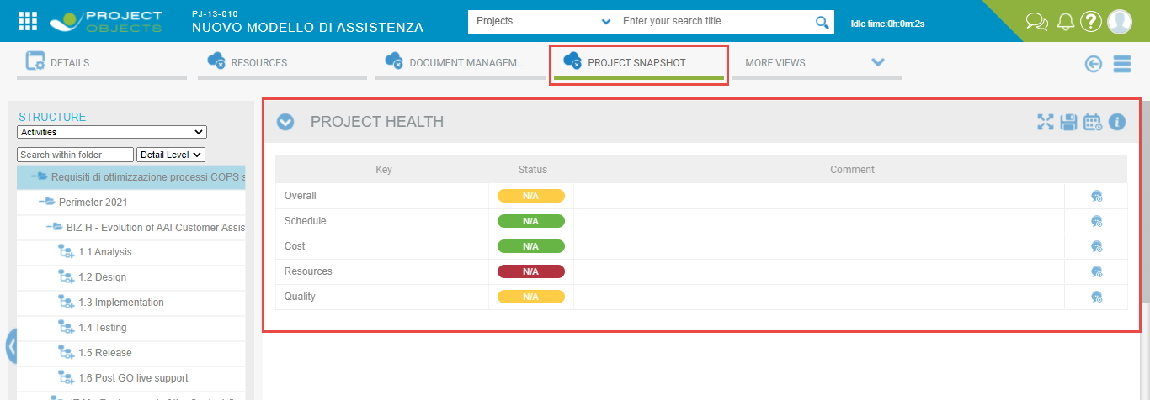

**Fig-Project Health Status**

**The list of fields included in API**

|  |  |  |  |
| --- | --- | --- | --- |
| **Sno.** | **Field Name** | **Field Description** | **Example** |
| 1 | Project Process Name | Process Name of existing Projects | Ideas & Projects Management |
| 2 | Project Type | Type of existing Projects that is Demand for Ideas / Project | Project |
| 3 | Portfolio | Portfolio name of Project associated with. | AX01 |
| 4 | Program | Program name of Project associated with. |  |
| 5 | Project Finish Date | Finish (Forecast) of existing projects | 2021-12-31T00:00:00 |
| 6 | Project Start Date | Start (Forecast) of existing projects | 2021-01-04T00:00:00 |
| 7 | Project Object Creation | Opening Date of existing projects | 2020-09-29T00:00:00 |
| 8 | Project State | State of existing Projects | In Progress |
| 9 | Project Actual Start | Actual Start Date of Project | 2021-01-04T00:00:00 |
| 10 | Project objLink | URL Path of existing Projects. |  |
| 11 | Project Actual Finish | Actual Finish Date of Project |  |
| 12 | Project Time Now | Time Now of existing Projects | 2021-03-09T00:00:00 |
| 13 | Priority | Priority of existing projects | HIGH |
| 14 | Project Code | Code of existing Projects | PJ-20-003 |
| 15 | Project Currency | Currency of existing Projects | EUR |
| 16 | Project Request type | Request Type of existing Projects | IT Projects |
| 17 | Project Requested By | User name of Project Requested By | Global System Administrator |
| 18 | Project Title | Title of existing Projects | IT Project Strategic |
| 19 | Project Workflow Step | Current Workflow name of existing projects | Create and Manage |
| 20 | Project IT Project Owner Area | Project Form field | IT P&S AIS |
| 21 | Project Reference Program | Project Form field |  |
| 22 | Project IT Project Manager | Project Form field | 0651054 - GIUSEPPE |
| 23 | Project Budget Allocation Type | Project Form field | Strategic |
| 24 | Project Assigned Budget | Project Form field | 532000 |
| 25 | Project IT Strategic Cluster | Project Form field | API |
| 26 | Project Business Strategic Cluster | Project Form field | Simplified Offer |
| 27 | Project Business Strategic Pillar | Project Form field | Easy |
| 28 | Project Line of Business | Project Form field | P&S |
| 29 | Project IT Strategic Pillar | Project Form field | Legacy API |
| 30 | Project Project Category | Project Form field | IT for Business |
| 31 | Key Code | Project Key Code | R01 |
| 32 | Key Title | Project Key Title | Overall |
| 33 | Key Description | Project Key Description | Test |
| 34 | KeyDate (GMT) | Project Key Date (Last saved date) | 2020-12-30T14:21:04 |
| 35 | Key Colour Code | Project Key Color | YELLOW |
| 36 | Comment By | Project Key Commented by username | [Admin@user.com](mailto:Admin@user.com) |
| 37 | Key Comment | Project Key Comment |  |
| 38 | Latitude | Latitude information as per Customer usage |  |
| 39 | Longitude | Longitude information as per Customer usage |  |
| 40 | Facility | Facility information as per Customer usage |  |
| 41 | Function | Function information as per Customer usage |  |
| 42 | Unit | Unit information as per Customer usage |  |

# TeamSpaceRegisterV2

The API contains the information related to the TeamSpace Processes which consists of Status Updates & Documents register data as per customer document Process.

**Source:** Application > Team Space Menu > Status Updates Register or Documents register

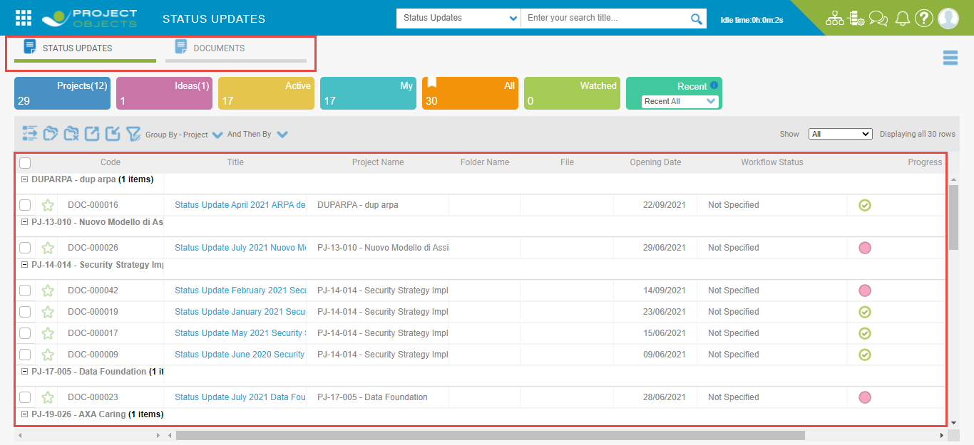

**Fig-TeamSpace Register**

**The list of fields included in API**

|  |  |  |  |
| --- | --- | --- | --- |
| **Sno.** | **Field Name** | **Field Description** | **Example** |
| 1 | Code | Code of Team Space Document | DOC-000001 |
| 2 | Title | Title of document | IT SMOM |
| 3 | Project Code | Code of Project associated with document | PJ-20-042 |
| 4 | Project Name | Name of Project associated with document | SMOM Project Objects setup |
| 5 | Process Name | Process Name of TeamSpace Sub-Menu | User Documents |
| 6 | Process Type | Process Type of TeamSpace Sub-Menu |  |
| 7 | Date | Opening Date of Document | 2021-02-09T00:00:00 |
| 8 | Request By | Username of document Requested By | CALIFANO ANNALAURA |
| 9 | Workflow Status | Workflow status of Document | Not Specified |
| 10 | Project | Associated Project code & Name of Document | PJ-20-042 - SMOM Project Objects setup |
| 11 | Owner | Owner of Document | Multiple owners |
| 12 | Folder Name | Folder name of Document |  |
| 13 | File | It is a null field due to its Data Type |  |
| 14 | Document Owner | Document form field |  |
| 15 | Document Type | Document form field |  |
| 16 | Document Status | Document Status |  |
| 17 | Project Process Name | Process Name of associated Projects of Document | Ideas & Projects Management |
| 18 | Project Type | Type of existing Projects that is Demand for Ideas / Project | Project |
| 19 | Portfolio | Portfolio name of Project associated with. | AX01 |
| 20 | Program | Program name of Project associated with. | PG-21-005 - IT Mat |
| 21 | Project Finish Date | Finish (Forecast) of Document projects | 2021-10-29T00:00:00 |
| 22 | Project Start Date | Start (Forecast) of Document projects | 2020-10-26T00:00:00 |
| 23 | Project Object Creation | Opening Date of Document projects | 2020-10-23T00:00:00 |
| 24 | Project State | State of document Projects | In Progress |
| 25 | Project Actual Start | Actual Start Date of Document Project | 2020-10-26T00:00:00 |
| 26 | Project objLink | URL Path of Document Project |  |
| 27 | Project Actual Finish | Actual Finish Date of document Project |  |
| 28 | Project Time Now | Time Now of document Projects | 2021-03-09T00:00:00 |
| 29 | Priority | Priority of document projects | HIGH |
| 30 | Project Currency | Currency of document Projects | EUR |
| 31 | Project Request type | Request Type of document Projects | IT Projects |
| 32 | Project Requested By | User name of Project Requested By of document | Global System Administrator |
| 33 | Project Title | Title of document Projects |  |
| 34 | ARPA decomm & Project Objects setup | Document form field |  |
| 35 | Project Workflow Step | Current Workflow name of existing projects | Create |
| 36 | Project IT Project Owner Area | Project Form field | IT STRATEGY |
| 37 | Project Reference Program | Project Form field | PG-21-005 - IT Mat |
| 38 | Project IT Project Manager | Project Form field | 0651251 - CHIMI |
| 39 | Project Budget Allocation Type | Project Form field | Strategic |
| 40 | Project Assigned Budget | Project Form field |  |
| 41 | Project IT Strategic Cluster | Project Form field | Modernization |
| 42 | Project Business Strategic Cluster | Project Form field |  |
| 43 | Project Business Strategic Pillar | Project Form field |  |
| 44 | Project Line of Business | Project Form field | TRANSFORMATION |
| 45 | Project IT Strategic Pillar | Project Form field | Legacy - API |
| 46 | Project Project Category | Project Form field | Pure IT |

# ProjectBasicCostAnnualPhasingV2

The API contains the information related to the Project Financials from Project Workspace “Costs Phasing” Item.

1. The Cost data is aggregated annually in the API.
2. The API includes all the Projects of Published (PB) state only. Unpublished (UP) will not be available in API.
3. Data is available in all three Currency types of Project, Company & Optional currency.
4. Data can be categorized using Input Type field filter as Entry (included Cost & Revenue elements total) & Resource (includes Resource cost total).
5. Data can also be categorized as Revenue (includes total of Revenue, Revenue resource elements) & Cost (includes total of Cost, Cost resource elements) using Element Type field filter in API.

**Source:** Application > Projects or Ideas Menu > Project or Ideas register > Select required Project > Project Workspace > Financials > Costs Phasing

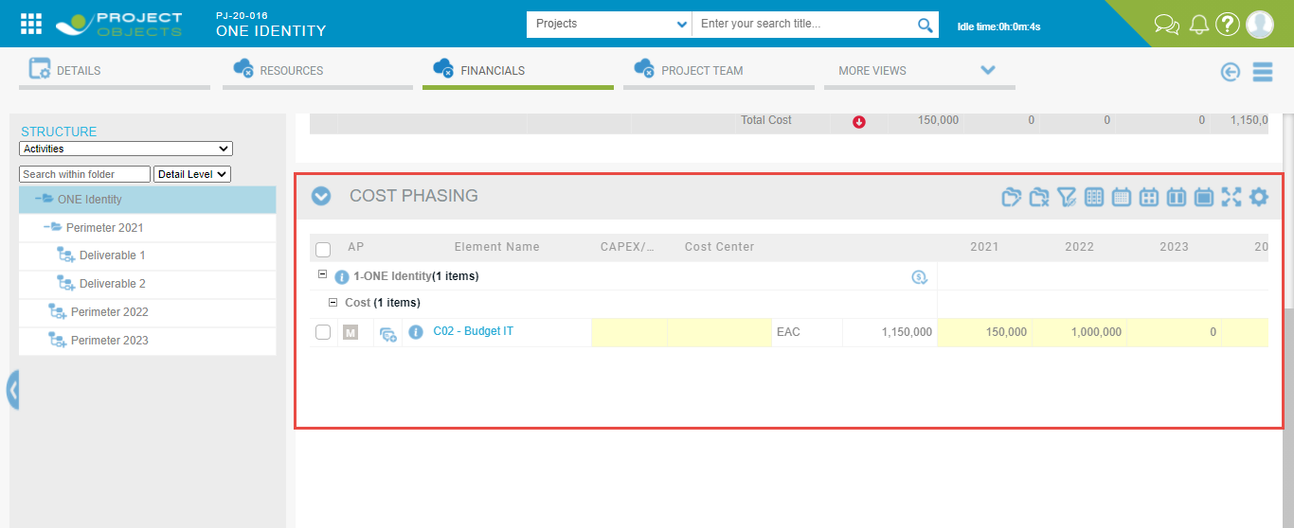

**Fig-Annual Cost Phasing**

**The list of fields included in API**

|  |  |  |  |
| --- | --- | --- | --- |
| **Sno.** | **Field Name** | **Field Description** | **Example** |
| 1 | Project Process Name | Process Name of Cost Projects | Ideas & Projects Management |
| 2 | Project Type | Type of Cost Projects that is Demand / Project | Demand |
| 3 | Portfolio | Portfolio name of Project associated with. | STR-002-Ideas |
| 4 | Program | Program name of Project associated with. |  |
| 5 | Project Finish Date | Finish (Forecast) of projects | 2022-12-31T00:00:00 |
| 6 | Project Start Date | Start (Forecast) of projects | 2022-01-04T00:00:00 |
| 7 | Project Object Creation | Opening Date of projects | 2020-10-12T00:00:00 |
| 8 | Project State | State of Projects | Draft |
| 9 | Project Actual Start | Actual Start Date of Project |  |
| 10 | Project Actual Finish | Actual Finish Date of Project |  |
| 11 | Project Time Now | Time Now of Projects | 2020-12-31T00:00:00 |
| 12 | Priority | Priority of projects | HIGH |
| 13 | Project Code | Code of Projects | PJ-21-084 |
| 14 | Project Currency | Currency of Projects | EUR |
| 15 | Project Request type | Request Type of Projects | IT Projects |
| 16 | Project Requested By | Username of Project Requested By | Global System Administrator |
| 17 | Project Title | Title of Projects | Digitalization |
| 18 | Project Workflow Step | Current Workflow name of projects | Manage |
| 19 | Project IT Project Owner Area | Project Form field | IT L&C |
| 20 | Project Reference Program | Project Form field |  |
| 21 | Project IT Project Manager | Project Form field |  |
| 22 | Project Budget Allocation Type | Project Form field | Strategic |
| 23 | Project Assigned Budget | Project Form field |  |
| 24 | Project IT Strategic Cluster | Project Form field |  |
| 25 | Project Business Strategic Cluster | Project Form field | Distribution Powered by Data |
| 26 | Project Business Strategic Pillar | Project Form field | Clear |
| 27 | Project Line of Business | Project Form field | TRANSFORMATION |
| 28 | Project IT Strategic Pillar | Project Form field |  |
| 29 | Project Project Category | Project Form field | Efficiency (Next) |
| 30 | Year | Project Cost Phasing Period | 2024 |
| 31 | Cost Type | Project Cost Type that is Opex , Capex & Undefined | Undefined |
| 32 | Element Type | Project Cost Element type that is Cost & Revenue | Revenue |
| 33 | Input Type | Input Type field having Entry (i.e. Cost + Revenue elements) & Resource values. | Resource |
| 34 | Currency Type | Project Cost Currency type ProjCurr (i.e Project Currency) , ConsCurr (i.e. Company Currency) & OptCurr (i.e Optional Currency) | OptCurr |
| 35 | Currency | Project Currency | EUR |
| 36 | Budget | Total Budget value of Cost Project |  |
| 37 | Actual | Total Actual value of Cost Project |  |
| 38 | ETC | Total ETC value of Cost Project |  |
| 39 | EAC | Total EAC value of Cost Project |  |
| 40 | Expenditure | Total Expenditure value of Cost Project |  |
| 41 | Project objLink | URL Path of Projects. |  |

# BasicCostSumMonthlyPhasingByProjects

The API contains the information related to the Project Financials from Project Workspace “Costs Phasing” Item where data is aggregated based on Yearly as well as Monthly Phasing.

1. The API includes all the Projects of Published (PB) state only. Unpublished (UP) will not be available in API.
2. Data is available in Project Currency only.
3. Activity & Element level Cost Data break-up is available in this API.
4. The Cost Data can be categorized based on Cost Element Type that is Cost, Cost Resource, Revenue & Revenue Resource.

**Source:** Application > Projects or Ideas Menu > Project or Ideas register > Select required Project > Project Workspace > Financials > Costs Phasing

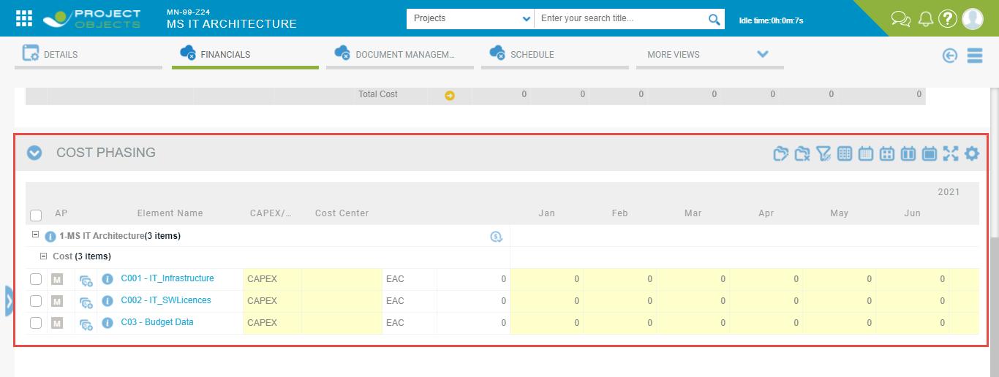

**Fig-Monthly Cost Phasing**

**The list of fields included in API**

|  |  |  |  |
| --- | --- | --- | --- |
| **Sno.** | **Field Name** | **Field Description** | **Example** |
| 1 | Process Name | Process Name of Project | Ideas & Projects Management |
| 2 | Type | Type of Cost Projects i.e. Demand as 1 & 0 as Project | 0 |
| 3 | Program | Program name of Project associated with. |  |
| 4 | Finish (Forecast) | Finish (Forecast) Date of projects | 2021-04-01T00:00:00 |
| 5 | Start (Forecast) | Start (Forecast) Date of projects | 2021-04-01T00:00:00 |
| 6 | Date | Opening Date of projects | 2020-09-29T00:00:00 |
| 7 | State | State of Projects | Draft |
| 8 | Actual Start | Actual Start Date of Project |  |
| 9 | Objectlink | URL Path of Projects. |  |
| 10 | Actual Finish | Actual Finish Date of Project |  |
| 11 | Time Now | Time Now of Projects |  |
| 12 | Currency | Currency of Projects | EUR |
| 13 | Current workflow name | Current Workflow name of projects | Create |
| 14 | Priority | Priority of projects |  |
| 15 | Project Code | Code of Projects | PJ-16-006 |
| 16 | Request type | Request Type of Projects | IT Projects |
| 17 | Requested By | Username of Project Requested By | Global System Administrator |
| 18 | Title | Title of Projects | OnBoarding |
| 19 | IT Project Owner Area | Project Form field | IT SOLUTIONS AIS |
| 20 | Reference Program | Project Form field |  |
| 21 | IT Project Manager | Project Form field | 0650975 - ANI RICCARDO |
| 22 | Budget Allocation Type | Project Form field | NA |
| 23 | Assigned Budget | Project Form field |  |
| 24 | IT Strategic Cluster | Project Form field |  |
| 25 | Business Strategic Cluster | Project Form field |  |
| 26 | Business Strategic Pillar | Project Form field |  |
| 27 | Line of Business | Project Form field | CUSTOMER |
| 28 | IT Strategic Pillar | Project Form field |  |
| 29 | Project Category | Project Form field | Non-Strategic Business |
| 30 | ProjectId1 | Project ID | 5027 |
| 31 | Budget (EUR) | Total Budget value of Project | 2000 |
| 32 | Actual (EUR) | Total Actual value of Project | 0 |
| 33 | EAC (EUR) | Total EAC value of Project | 2000 |
| 34 | ETC (EUR) | Total ETC value of Project | 2000 |
| 35 | TotalBaselineWork | Total Baseline work of Project as per Resource assignment. | 125 |
| 36 | TotalForecastWork | Total Forecast work of Project as per Resource assignment. | 125 |
| 37 | TotalActualWork | Total Actual work of Project as per Resource assignment. | 0 |
| 38 | Portfolio | Code & Name of Portfolio where Project is associated | AX01 |
| 39 | Element Code | Element Codes |  |
| 40 | Element Name | Element Names | LUCA |
| 41 | Activity Name | Activity Names Where Cost Element is added. | 1.1-Perimeter |
| 42 | Year | Cost Phasing Period in Years | 2024 |
| 43 | Month | Cost Phasing Period in Months | 4 |
| 44 | Cost Type | Cost Type (Capex, Opex & Undefined) | Opex |
| 45 | Element Type | Element Type (Cost, Cost Resource, Revenue & Revenue Resource) | Cost Resource |
| 46 | Budget | Total Budget value of Project | 0 |
| 47 | Actual | Total Actual value of Project | 0 |
| 48 | ETC | Total EAC value of Project | 0 |
| 49 | EAC | Total ETC value of Project | 0 |

# PortfolioMetricV2

The API contains the information related to the Project Portfolio Metrics from Portfolio workspace “Metrics” & “Projects” layout.

**Source:** Application > Portfolios Menu > Portfolio Workspace > Metrics

**Fig-Project Portfolio Metrics**

**Source:** Application > Portfolios Menu > Portfolio Workspace > Modelling > Projects > Edit Metrics

**Fig-Portfolio Edit Metrics**

**The list of fields included in API**

|  |  |  |  |
| --- | --- | --- | --- |
| **Sno.** | **Field Name** | **Field Description** | **Example** |
| 1 | Project Process Name | Process Name of Project | Ideas & Projects Management |
| 2 | Project Type | Type of Cost Projects that is Demand for Ideas / Project | Demand |
| 3 | Portfolio | Portfolio name of Project associated with. | STR-002-Ideas |
| 4 | Program | Program name of Project associated with. |  |
| 5 | Project Finish Date | Finish (Forecast) of projects | 2023-06-30T00:00:00 |
| 6 | Project Start Date | Start (Forecast) of projects | 2022-01-04T00:00:00 |
| 7 | Project Object Creation | Opening Date of projects | 2020-10-21T00:00:00 |
| 8 | Project State | State of Projects | Draft |
| 9 | Project Actual Start | Actual Start Date of Project |  |
| 10 | Project Actual Finish | Actual Finish Date of Project |  |
| 11 | Project Time Now | Time Now of Projects | 2019-12-31T00:00:00 |
| 12 | Priority | Priority of projects | HIGH |
| 13 | Project Code | Code of Projects | PJ-21-098 |
| 14 | Project Currency | Currency of Projects | EUR |
| 15 | Project Request type | Request Type of Projects | IT Projects |
| 16 | Project Requested By | Username of Project Requested By | Global System Administrator |
| 17 | Project Title | Title of Projects | Data Platform |
| 18 | Project Workflow Step | Current Workflow name of projects | Create |
| 19 | Project IT Project Owner Area | Project Form field |  |
| 20 | Project Reference Program | Project Form field |  |
| 21 | Project IT Project Manager | Project Form field |  |
| 22 | Project Budget Allocation Type | Project Form field | Strategic |
| 23 | Project Assigned Budget | Project Form field |  |
| 24 | Project IT Strategic Cluster | Project Form field |  |
| 25 | Project Business Strategic Cluster | Project Form field | Distribution Powered by Data |
| 26 | Project Business Strategic Pillar | Project Form field | Easy & Clear |
| 27 | Project Line of Business | Project Form field | AMFF |
| 28 | Project IT Strategic Pillar | Project Form field |  |
| 29 | Project Project Category | Project Form field | Efficiency (Next) |
| 30 | Currency | Portfolio Metric currency | EUR |
| 31 | Metric Rating | Portfolio Metric Rating | 10 |
| 32 | Metric Title | Portfolio Metric Title | Level of Importance |
| 33 | Metric Code | Portfolio Metric Code | M01 |
| 34 | Metric Weight | Portfolio Metric Weight | 100 |
| 35 | Category Weight | Portfolio Metric Category Weight | 100 |
| 36 | Metric Category | Portfolio Metric Category Name | Business |
| 37 | Portfolio Title | Portfolio Title | CPO Portfolio |
| 38 | Demand/Project |  | Demand |
| 39 | Portfolio Code | Portfolio Code | STR-002 |
| 40 | Risk Score(Average) | Portfolio Metric Risk (Average) |  |
| 41 | Form Type | Portfolio Metric Form Type | IDEA |
| 42 | Metric Value | Portfolio Metric Value | 10 |
| 43 | Metric Ranking | Portfolio Metric Ranking | High |
| 44 | Forecast ConsCurr | Project Forecast cost in Company Currency | 45000 |
| 45 | Forecast ProjCurr | Project Forecast cost in Project Currency | 45000 |
| 46 | Forecast OptCurr | Project Forecast cost in Optional Currency | 45000 |
| 47 | Budget ConsCurr | Project Budget cost in Company Currency | 45000 |
| 48 | Budget ProjCurr | Project Budget cost in Project Currency | 45000 |
| 49 | Budget OptCurr | Project Budget cost in Optional Currency | 45000 |
| 50 | Project objLink | URL Path of Projects. |  |

# GenericResourceAvailabilityViewV2

The API contains the information related to Resource availability & work from Project Workspace Resource Phasing Grid.

**Source 1:** Application > Projects Menu > Project Workspace > Resources > Resource Phasing Widget

**Fig-Resource Phasing**

**Source 2:** Application > Explorer > Resource Availability View > Net Availability View

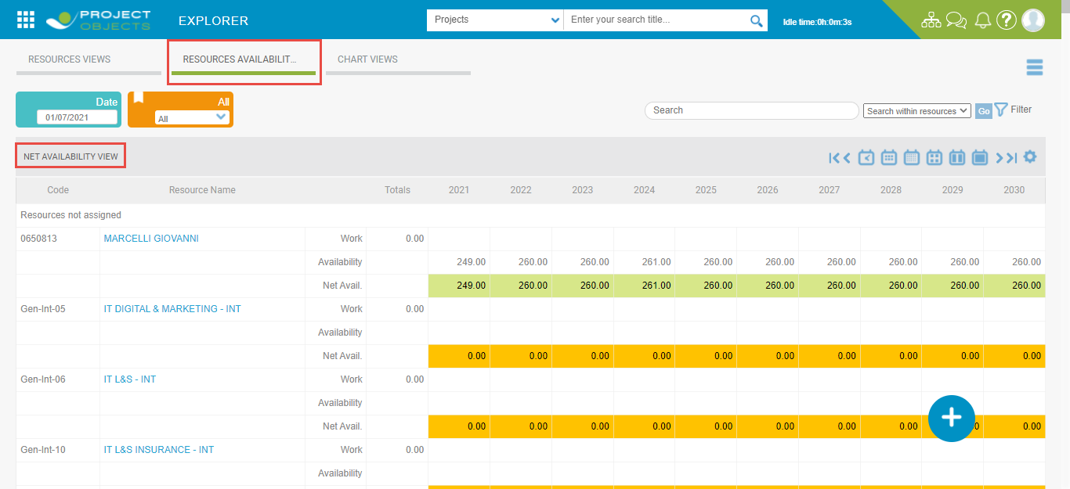

**Fig-Resource Availability View**

**The list of fields included in API**

|  |  |  |  |
| --- | --- | --- | --- |
| **Sno.** | **Field Name** | **Field Description** | **Example** |
| 1 | Project Process Name | Process Name of Project | Ideas & Projects Management |
| 2 | Project Type | Type of Cost Projects that is Demand for Ideas / Project | Project |
| 3 | Portfolio | Portfolio name of Project associated with. | BA-001- Maintenance |
| 4 | Program | Program name of Project associated with. |  |
| 5 | Project Finish Date | Finish (Forecast) of projects | 2021-12-31T00:00:00 |
| 6 | Project Start Date | Start (Forecast) of projects | 2021-01-01T00:00:00 |
| 7 | Project Object Creation | Opening Date of projects | 2020-09-30T00:00:00 |
| 8 | Project State | State of Projects | Draft |
| 9 | Project Actual Start | Actual Start Date of Project |  |
| 10 | Project Actual Finish | Actual Finish Date of Project |  |
| 11 | Project Time Now | Time Now of Projects | 2019-12-31T00:00:00 |
| 12 | Priority | Priority of projects |  |
| 13 | Project Code | Code of Projects | MN-99-Z23 |
| 14 | Project Currency | Currency of Projects | EUR |
| 15 | Project Request type | Request Type of Projects | IT Projects |
| 16 | Project Requested By | Username of Project Requested By | Global System Administrator |
| 17 | Project Title | Title of Projects | MS IT |
| 18 | Project Workflow Step | Current Workflow name of projects | Create |
| 19 | Project IT Project Owner Area | Project Form field | IT STRATEGY AIS |
| 20 | Project Reference Program | Project Form field |  |
| 21 | Project IT Project Manager | Project Form field | 0651055 - GHA |
| 22 | Project Budget Allocation Type | Project Form field | Strategic |
| 23 | Project Assigned Budget | Project Form field |  |
| 24 | Project IT Strategic Cluster | Project Form field |  |
| 25 | Project Business Strategic Cluster | Project Form field |  |
| 26 | Project Business Strategic Pillar | Project Form field |  |
| 27 | Project Line of Business | Project Form field | TRANSFORMATION |
| 28 | Project IT Strategic Pillar | Project Form field |  |
| 29 | Project Project Category | Project Form field | Maintenance IT |
| 30 | Project objLink | URL Path of Projects. |  |
| 31 | Resource Name | Resource name | CALIFANO |
| 32 | Named / Generic | Named / Generic | Named |
| 33 | Internal / External | Internal / External | External |
| 34 | Resource Type | Resource Type |  |
| 35 | Work Type | Work Type as Standard work or Unassigned | Standard Work |
| 36 | Year | Resource Phasing Period in Year | 2022 |
| 37 | Month | Resource Phasing Period in Month | 1 |
| 38 | Baseline Work By Hours | Total Baseline Work by Hours of Resource |  |
| 39 | Baseline Work By Days | Total Baseline Work by Days of Resource |  |
| 40 | Baseline Work By Months | Total Baseline Work by Months of Resource |  |
| 41 | Forecast Work By Hours | Total Forecast Work by Hours of Resource | 45.574292 |
| 42 | Forecast Work By Days | Total Forecast Work by Days of Resource | 5.6967865 |
| 43 | Forecast Work By Months | Total Forecast Work by Months of Resource | 0.299830868 |
| 44 | Actual Work By Hours | Total Actual Work by Hours of Resource | 12 |
| 45 | Actual Work By Days | Total Actual Work by Days of Resource | 1.5 |
| 46 | Actual Work by Months | Total Actual Work by Months of Resource | 0.078947368 |
| 47 | Department | Department of Resource | IT STRATEGY AIS |
| 48 | Project Job Title | Project Job Title of Resource | IT Governance |
| 49 | Working Hrs. / Day | Total Working Hrs. of Resource as per Calendar | 8 |
| 50 | Availability % | Resource Max Availability % as per Resource calendar | 100 |
| 51 | Resource Availability Hours Per Month | Total resource availability as per Resource Phasing in Hours | 152 |
| 52 | Resource Availability Days Per Month | Total resource availability as per Resource Phasing in Days | 19 |
| 53 | Resource Availability Month Per Month | Total resource availability as per Resource Phasing in Month | 1 |

# ScheduleDataV2

The API contains the information related to Project Activities & Tasks from Project workspace Schedule View.

**Source:** Application > Projects or Ideas Menu > Project or Ideas register > Select required Project > Project Workspace > Schedule > Schedule View

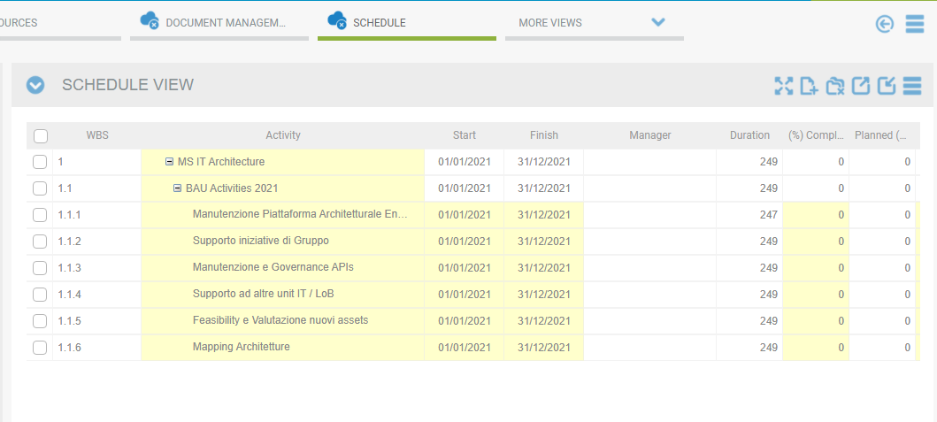

**Fig-Project Schedule View**

**The list of fields included in API**

|  |  |  |  |
| --- | --- | --- | --- |
| **Sno.** | **Field Name** | **Field Description** | **Example** |
| 1 | Project Process Name | Process Name of Project | Ideas & Projects Management |
| 2 | Project Type | Type of Cost Projects that is Demand for Ideas / Project | Project |
| 3 | Portfolio | Portfolio name of Project associated with. | BA-002-Non-Strategic Business |
| 4 | Program | Program name of Project associated with. | PG-21-005 - IT Maturity |
| 5 | Project Finish Date | Finish (Forecast) of projects | 2021-04-01T00:00:00 |
| 6 | Project Start Date | Start (Forecast) of projects | 2021-04-01T00:00:00 |
| 7 | Project Object Creation | Opening Date of projects | 2020-09-29T00:00:00 |
| 8 | Project State | State of Projects | Draft |
| 9 | Project Actual Start | Actual Start Date of Project |  |
| 10 | Project Actual finish | Actual Finish Date of Project |  |
| 11 | Project Time Now | Time Now of Projects | 2017-12-31T00:00:00 |
| 12 | Priority | Priority of projects |  |
| 13 | Project Code | Code of Projects | PJ-16-006 |
| 14 | Project Currency | Currency of Projects | EUR |
| 15 | Project Request type | Request Type of Projects | IT Projects |
| 16 | Project Requested By | Username of Project Requested By | Global System Administrator |
| 17 | Project Title | Title of Projects | OnBoarding |
| 18 | Project Workflow Step | Current Workflow name of projects | Manage |
| 19 | Project IT Project Owner Area | Project Form field | IT SOLUTIONS AIS |
| 20 | Project Reference Program | Project Form field | PG-21-005 - IT Maturity |
| 21 | Project IT Project Manager | Project Form field | 0650975 - CARDO |
| 22 | Project Budget Allocation Type | Project Form field |  |
| 23 | Project Assigned Budget | Project Form field | 54000 |
| 24 | Project IT Strategic Cluster | Project Form field |  |
| 25 | Project Business Strategic Cluster | Project Form field |  |
| 26 | Project Business Strategic Pillar | Project Form field |  |
| 27 | Project Line of Business | Project Form field | CUSTOMER |
| 28 | Project IT Strategic Pillar | Project Form field |  |
| 29 | Project Project Category | Project Form field | Non-Strategic Business |
| 30 | Project objLink | URL Path of Projects. |  |
| 31 | WBS | WBS of Project Schedule view | 1 |
| 32 | Activity | Activity name of Project Schedule view | Onboarding |
| 33 | Task Start | Activity Start date | 2021-04-01T00:00:00 |
| 34 | Task Finish | Activity Finish date | 2021-04-01T00:00:00 |
| 35 | Manager | Manager of Task |  |
| 36 | Duration | Duration of Task | 1 |
| 37 | (%) Complete | (%) Complete of task |  |
| 38 | Planned (%) Complete | Planned (%) Complete of task |  |
| 39 | Physical (%) Complete | Physical (%) Complete of task |  |
| 40 | Baseline Start | Baseline Start Date of task |  |
| 41 | Baseline Finish | Baseline Finish Date of task |  |
| 42 | Baseline Duration | Baseline Duration Date of task |  |
| 43 | Actual Start | Actual Start Date of task |  |
| 44 | Actual Finish | Actual Finish Date of task |  |
| 45 | Actual Duration | Actual Duration of task |  |
| 46 | Remaining Duration | Remaining Duration of Project Schedule view | 1 |
| 47 | Weight (%) | Weight (%) of task |  |

# TTReport

The API contains the information related to the existing Timesheets created by users as per its State from Time Tracking module.

**Source:** Application > Time Menu > Time Sheet register (Current, Pending & Approved)

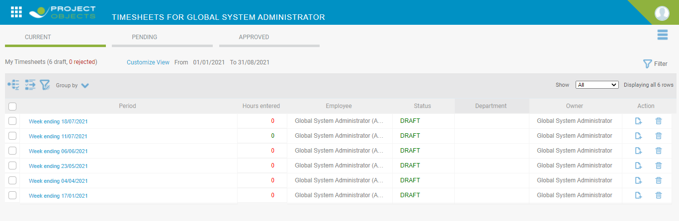

**Fig-Time Tracking**

**The list of fields included in API**

|  |  |  |  |
| --- | --- | --- | --- |
| **Sno.** | **Field Name** | **Field Description** | **Example** |
| 1 | Project Code | Code of Projects | PJ-18-201 |
| 2 | Budget Allocation Type | Project Budget allocation type | Strategic |
| 3 | Project Category | Project Category | Regulatory |
| 4 | Project Name | Title of Project | International |
| 5 | Task Name | Task Names as per existing Timesheets | 1-International |
| 6 | Project Manager | Project Manager | ALESSANDRO |
| 7 | Resource Name | Time Sheet Creator | BALLIRANO |
| 8 | Job Title | Job Title of Resource |  |
| 9 | Department | Department of Resources | IT CORPORATE |
| 10 | Resource Type | Resource Type | Internal |
| 11 | Week | Existing Timesheet Week | 17-Jan |
| 12 | Year | Existing Timesheet Year | 2022 |
| 13 | Timesheet Status | Status of Timesheets Draft, Approved. | Pending |
| 14 | Task Status | Task Status | Approved |
| 15 | Hours | Total Hours Spent as per Timesheet | 2 |
| 16 | Days | Total Days Spent as per timesheet | 0.25 |

# PortfolioProjectRegister

The API contains the information related to the Portfolio Module where Projects are associated. It includes Portfolio workspace Projects register data as shown in Image below.

**Source:** Application > Portfolios Menu > Modeling > Projects

**Fig-Projects Portfolio Register**

**The list of fields included in API**

|  |  |  |  |
| --- | --- | --- | --- |
| **Sno.** | **Field Name** | **Field Description** | **Example** |
| 1 | Process Name | Process Name of Project | Ideas & Projects Management |
| 2 | Type | Type of Cost Projects i.e., Demand as 1 & 0 as Project | 0 |
| 3 | Program | Program name of Project associated with. | PG-21-005 - IT Maturity |
| 4 | Finish (Forecast) | Finish (Forecast) of projects | 2021-04-01T00:00:00 |
| 5 | Start (Forecast) | Start (Forecast) of projects | 2021-04-01T00:00:00 |
| 6 | Date | Opening Date of projects | 2020-09-29T00:00:00 |
| 7 | State | State of Projects | Draft |
| 8 | Actual Start | Actual Start Date of Project |  |
| 9 | Objectlink | URL Path of Projects. |  |
| 10 | Actual Finish | Actual Finish Date of Project |  |
| 11 | Time Now | Time Now of Projects | 2017-12-31T00:00:00 |
| 12 | Currency | Currency of Projects | EUR |
| 13 | Current workflow name | Current Workflow name of projects | Manage |
| 14 | Priority | Priority of projects |  |
| 15 | Project Code | Code of Projects | PJ-16-006 |
| 16 | Request type | Request Type of Projects | IT Projects |
| 17 | Requested By | Username of Project Requested By | Global System Administrator |
| 18 | Title | Title of Projects | OnBoarding |
| 19 | IT Project Owner Area | Project Form field | IT SOLUTIONS AIS |
| 20 | Reference Program | Project Form field | PG-21-005 - IT Maturity |
| 21 | IT Project Manager | Project Form field | 0650975 - CARDO |
| 22 | Budget Allocation Type | Project Form field |  |
| 23 | Assigned Budget | Project Form field | 54000 |
| 24 | IT Strategic Cluster | Project Form field |  |
| 25 | Business Strategic Cluster | Project Form field |  |
| 26 | Business Strategic Pillar | Project Form field |  |
| 27 | Line of Business | Project Form field | CUSTOMER |
| 28 | IT Strategic Pillar | Project Form field |  |
| 29 | Project Category | Project Form field | Non Strategic Business |
| 30 | ProjectId1 | Project ID | 5027 |
| 31 | Budget (EUR) | Total Budget value of Project |  |
| 32 | Actual (EUR) | Total Actual value of Project |  |
| 33 | EAC (EUR) | Total EAC value of Project |  |
| 34 | ETC (EUR) | Total ETC value of Project |  |
| 35 | TotalBaselineWork | Total Baseline work of Project as per Resource assignment. |  |
| 36 | TotalForecastWork | Total Forecast work of Project as per Resource assignment. | 117 |
| 37 | TotalActualWork | Total Actual work of Project as per Resource assignment. |  |
| 38 | Portfolio | Code & Name of Portfolio where Project is associated | BA-002- Non Strategic Business |
| 39 | Scenario | Scenario of Portfolio | Current version |
| 40 | In/Out | In/Out of Project as per Portfolio register | OUT |
| 41 | Portfolio Decisions | Portfolio Decisions of Project as per Portfolio register | No Decision |
| 42 | Rating | Rating of Project |  |
| 43 | Edit Metric | Edit Metric of Project as per Portfolio register |  |
| 44 | Portfolio Start (Forecast) | Portfolio Start Date | 4/1/2021 |
| 45 | Portfolio Finish (Forecast) | Portfolio Finish Date | 4/1/2021 |
| 46 | Schedule | Schedule Key on Project as per portfolio register | 0 |
| 47 | Resource | Resource Key on Project as per portfolio register | -1 |
| 48 | Portfolio Budget | Portfolio Budget as per Portfolio register | 0 |
| 49 | Portfolio Baseline Work | Total Portfolio Baseline Work |  |
| 50 | Portfolio Forecast Work | Total Portfolio Forecast Work | 117 |
| 51 | Portfolio Actual Work | Total Portfolio Actual Work | 0 |
| 52 | Portfolio Baseline Costs | Total Portfolio Baseline Costs | 41400 |
| 53 | Portfolio Forecast Costs | Total Portfolio Forecast Costs | 41400 |
| 54 | Portfolio Actual Costs | Total Portfolio Actual Costs |  |
| 55 | Baseline Benefits | Baseline Benefits of Project as per Portfolio register |  |
| 56 | Forecast Benefits | Forecast Benefits of Project as per Portfolio register |  |
| 57 | Actual Benefits | Actual Benefits of Project as per Portfolio register |  |
| 58 | Baseline NPV | Baseline NPV of Project as per Portfolio register |  |
| 59 | Forecast NPV | Forecast NPV of Project as per Portfolio register |  |
| 60 | NPV | NPV of Project as per Portfolio register |  |
| 61 | Baseline ROI | Baseline ROI of Project as per Portfolio register | -100 |
| 62 | Forecast ROI | Forecast ROI of Project as per Portfolio register | -100 |
| 63 | ROI | ROI of Project as per Portfolio register |  |
| 64 | Risk Score (Average) | Risk Score (Average) of Project as per Portfolio register |  |

# GroupDetails

The API contains the information related to the Group Settings from Company Configurations.

**Source:** Application > Configuration Menu > Groups > Manage Groups > Edit Information.

**Fig-Groups**

**The list of fields included in API**

|  |  |  |  |
| --- | --- | --- | --- |
| **Sno.** | **Field Name** | **Field Description** | **Example** |
| 1 | Group | Group Name | 0 |
| 2 | Group Description | Group Description | Global Administrator |
| 3 | GA Edit Only | Global Administrator Edit only | No |
| 4 | Homepage Dashboard | Name of current selected Home Page Dashboard | Executive Dashboards |
| 5 | Project Workspace Dashboard | Name of current selected Workspace Page Dashboard if any | null |
| 6 | Nr of users associated | Total Number of users associated with Group | 3 |
| 7 | System Admin Role | Has System Admin Role? | Yes |
| 8 | Local Admin Role | Has Local Admin Role? | No |
| 9 | Stage Owner Role | Has Stage Owner Role? | Yes |
| 10 | Organization | Name of Organization | Demo |
| 11 | Gate Keeper Role | Has Gate keeper Role? | Yes |

# AuditTrail

The API contains the information related to Audit log of every user accessing the application.

**Source:** Application > Configuration Menu > Access log > Audit Trail

**Fig-Access Log**

**The list of fields included in API**

|  |  |  |  |
| --- | --- | --- | --- |
| **Sno.** | **Field Name** | **Field Description** | **Example** |
| 1 | UserName | Full Username | Test |
| 2 | Email | Login User Email address | ADMIN@TEST.IT |
| 3 | Tracktime | User login / Logoff Time & Date | 2021-03-15T09:41:15 |
| 4 | Module | Logon Form as Module | Logonform |
| 5 | SubModule | Logon as Sub module | Logon |
| 6 | OperationType | Login or Logout Operation type | Login |
| 7 | OperationDESC | Login / Logout Operations description as Per user access. | admin@test.com has logged in to application |
| 8 | Browser Type | Logged in User's Browser Type | Chrome-89.0 |
| 9 | COS Node | COS Node |  |
| 10 | Area | Cos Node - Area |  |
| 11 | CEO | Cos Node - CEO |  |
| 12 | Company | Cos Node - Company |  |
| 13 | Department | Cos Node - Department |  |
| 14 | Facility | Cos node |  |
| 15 | Function | Cos Node - Function |  |
| 16 | Unit | Cos Node - Unit |  |

# UserDetails

The API contains the information related to all the Users existing in System from Users configuration Settings as shown in Image below.

**Source:** Application > Configuration Menu > Users > Manage Users > Edit Information.

**Fig-Users**

**The list of fields included in API**

|  |  |  |  |
| --- | --- | --- | --- |
| **Sno.** | **Field Name** | **Field Description** | **Example** |
| 1 | UserName | Full Username | Test |
| 2 | UserDescription | User Description | Global System Admin |
| 3 | Email | Email address of User | ADMIN@TEST.IT |
| 4 | IsFormAuth | Enable user to use form authentication | Yes |
| 5 | IsTwoFactor |  | No |
| 6 | IsActive | User status Active or Inactive | Active |
| 7 | IsInternal | User Type Internal or External | Internal |
| 8 | HasResource | Add as resource (radio button) | Yes |
| 9 | Modified | Last modification of User Details Date | 2021-06-04T00:00:00 |
| 10 | Created | Created Date of User | 2018-01-25T11:28:41.95 |
| 11 | Group | User associated Group Name | 0 |
| 12 | Group Description | User associated Group Description | Global Administrator |
| 13 | Organization | Organization name | Demo-Demo |
| 14 | LastLogged | Last application login date of User | 2021-06-04T00:00:00 |
| 15 | COS Node | COS Node |  |
| 16 | Area | Cos Node - Area |  |
| 17 | CEO | Cos Node - CEO |  |
| 18 | Company | Cos Node - Company |  |
| 19 | Department | Cos Node - Department |  |
| 20 | Facility | Cos Node |  |
| 21 | Function | Cos Node - Function |  |
| 22 | Unit | Cos Node - Unit |  |

# StandardCodes

The API contains the Code & Title of the tables of Standard Codes Configuration Settings Modules. For example, General Module, Customers/Suppliers Codes & Names.

**Source:** Application > Configuration Menu > Standard Codes > Modules > Sub Modules > Item Grid > Code & Description Column.

**Fig-Customers/Suppliers**

**The list of fields included in API**

|  |  |  |  |
| --- | --- | --- | --- |
| **Sno.** | **Field Name** | **Field Description** | **Example** |
| 1 | Module | Standard Codes Module Names (Tabs) i.e. General, Cost Management, Project Management, Project Requests, Resource Management, Strategy & Portfolio Management, Time Tracking etc. | General |
| 2 | TYPE | Standard Codes Sub Module Names (Sub-Tabs) | Customers |
| 3 | Code | Code of Sub-Module Input e.g., Customer Code | A000000027 |
| 4 | Title | Title of Sub-Module Input e.g., Customer Name | ELETTROTEAM SRL |

# StandardCodesDataExtendedLibrary

The API contains the Code & Title of the tables of Standard Codes General & Cost management Module’s COS Master Data and Cost Extended Library table information only (If exists for a customer) as shown in image below.

For example, General Module, COS Master Data Code, Title & Alias.

**Source:** Application > Configuration Menu > Standard Codes > Module - General > COS Master Data > Item Grid > Alias, Code & Description Column.

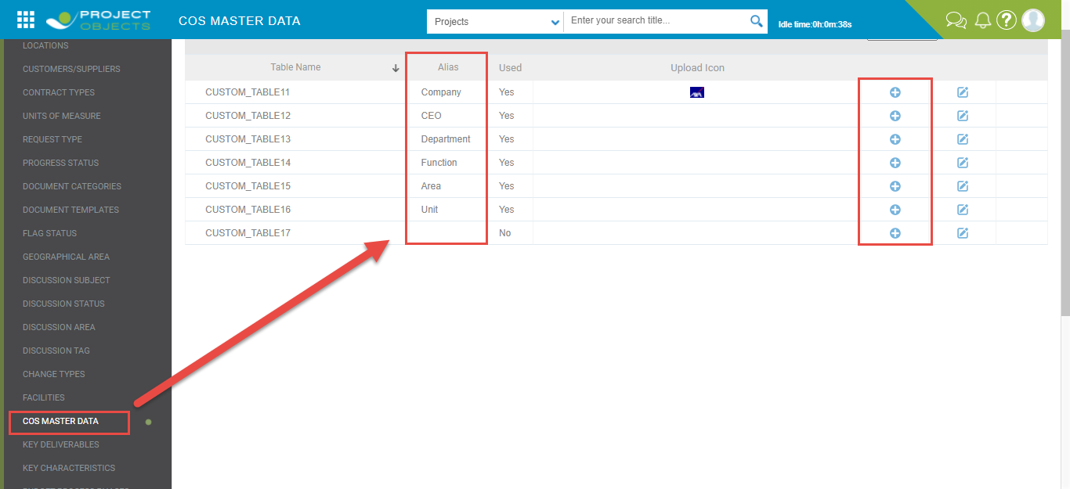

**Fig-COS Master Data (Alias)**

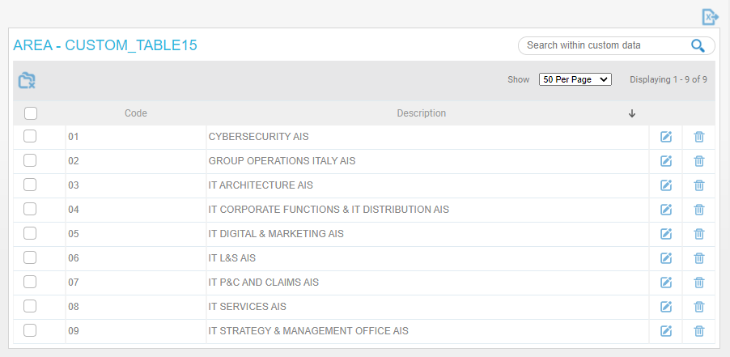

**Fig-Areas (Code & Title)**

**The list of fields included in API**

|  |  |  |  |
| --- | --- | --- | --- |
| **Sno.** | **Field Name** | **Field Description** | **Example** |
| 1 | Module | Standard Codes - General Module & Cost Management Module | General |
| 2 | TYPE | Standard Codes - Sub Module COS Master Data & Cost Extended Library | COS Master Data |
| 3 | Code | Code of Sub-Module Input | 1 |
| 4 | Alias | Alias of Sub-Module Input | Area |
| 5 | Title | Title of Sub-Module Input | SECURITY AIS |

# LastPublishedDateTime

The API records all the other JSON APIs last Published Date & Time information.

**The list of fields included in API**

|  |  |  |  |
| --- | --- | --- | --- |
| **Sno.** | **Field Name** | **Field Description** | **Example** |
| 1 | Api Name | Name of JSON API | PortfolioProjectRegister |
| 2 | Last Updated | Date & Time of API last Publish | 06/17/2021 04:55:35 |